Axis 2 Architecture Guide

Table of contents
Axis 2 Architecture Guide i
Table of contents i
1.1 Introduction 1
1.2 Architecture overview 1
1.3 Axis2 sub components 1
2.0 Axis Engine 1
3.0 Engine Registry 1
4.0 Message Context 1
5.0 Deployment 1
5.1 Module deployment: 1
5.2 Service Deployment 1
5.4 Scheduler 3
5.5 Listener 3
5.6 Repository 4
5.7 DeploymentEngine 4
5.8 DeploymentParser 4
5.8 Deployment Engine initialization 4
5.9 Adding new web service 5
6.0 Axis Object Model 5
7.0 Handler Frame work and Phase Rules 5
7.1 Phase 5
7.2 Handler chain 6
8.0 WSDL Object model. 6
9.0 Client API. 6
9.1 sendAsync Invocation 7
9.2 send Invocation 8
9.3 sendReceive Invocation 8
9.4 sendReceiveAsync Invocation 9
9.5 sendReceiveAsync Invocation with One way transport 9

Introduction
This document describes some of the rationale of the architecture and design of Axis2.

1.2 Architecture overview
Axis consists of several sub components working together, as we shall see later. In this section
We will give you an overview of how the core of Axis works.

1.3 Axis2 sub components
Axis2 consists of following high level sub components, and those are described one by one in the document.
- Engine
- Engine Registry
- Message Context
- Deployment
- Axis Object Model (AXIOM)
- Handler framework and Phase rules
- WSDL Object model.
- Client API.

2.0 Axis Engine
<<< Srinath will complete >>>
<<< Including complete incoming and out going paths >>>

3.0 Engine Registry
<<< Srinath will complete >>>

4.0 Message Context
<<< Srinath will complete >>>

5.0 Deployment
There are two types of deployment in Axis2, namely; service deployment and module deployment.

5.1 Module deployment:
Axis 2 provides J2EE like deployment for both modules and services. User can deploy a module or a service as an “.aar” file (module1.aar , service1.aar). Module hot deployment will not be supported in M1, but will be supported in later releases. When the axis engine get starts all the aar files in the WEB-INF/Repository/modules will get deployed. But if someone wants to add a new restarting of the engine is required, after putting the new .aar file in the above mentioned folder.

5.2 Service Deployment
One of the key improvements introduced with Axis 2 is the capability to “hot deploy” web services. And in this M1 release only J2EE like deployment is supported. <Comment : the word j2ee like deployment may have its own meaning. I know that you have tried to mention that just drop-in thing. But when u say that thing using this sentence, will people think something different ?? >i.e. user has to build an aar file including all his classes and lib files, and put that in to WEB-INF/Repository/services directory. Following three features are associated with service deployment;
- Hot Deployment
- Hot un deployment
- Hot update
Hot Deployment is all about the ability to of deploying new web service while the axis engine is up and running.
Hot un-deployment is ability to remove a web service (services) while the system is running.
Hot update is ability deploy new version of existing web service without restarting the server. And it is handling as un -deployment followed by a hot deployment.
The directory structure that modules and services should deployed.
- WEB-INF/Repository/modules
- WEB-INF/Repository/services

The required directory structure for a modules archive file is as follows;
m1.aar
META-INF/module.xml
lib/
classes/

The required directory structure for a service archive file is as follows;
s1.aar
META-INF/service.xml
lib/
classes/

The structure of module.xml file looks like as follows;
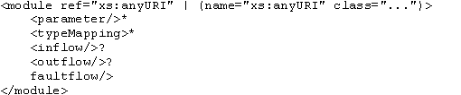
The structure of service.xml file looks like as;
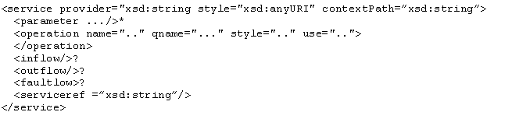

The architecture of hot deployment consists of the following components;
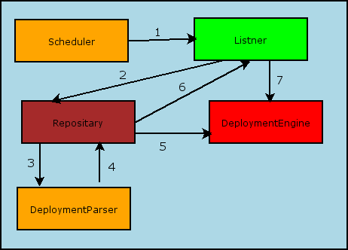
<Comment : Check spellings of green, and brown boxes>
- Scheduler periodically invokes listener to check for updates
- If Listener found an update it passes that information to the Repositary
- Repository hand over the document to DeploymentParser
- Having parsed the document, the DeploymentParser returns the corresponding object
- update the toDeploy and toUnDeploy list
- inform Listener to update system
- inform DeploymentEngine to do update (both deploy and undeploy)

5.4 Scheduler
This component itself is a thread and performs a specific task forever in given time interval. In this case it is periodically ask Listener to listen to the file system events. Here the file system is not the entire file system it is only the sub directories of WEB_INF/Repository that is modules and services.

5.5 Listener
As mentioned above Listener listen to file system events, it checks both the modules and services directories. Then lists all the archive files in those two directories, next compare those against the repository to check whether new service(s) has added or any service(s) has been modified. And then it informs DeploymentEngine to execute the required methods.

5.6 Repository
Repository stores data about already deployed modules and services. At the initialization process this loads data about all the modules and services in the module and service directories. And then deploy all those loaded modules and services. The repository store data about name of the archive file and the last modified date. And it can be possible to perform following operation to Repository;

- Add new entry to Repository
- Remove entry from Repository ,and
- Modify entry in the Repository.
Those operations correspond to Hot Deployment, Hot unDeployment and Hot Update.
In the add operation it check whether the entry which is going to add already in the Repository if so it ignore the operation else it will add the entry to Repository and also it would add an entry to a list maintaining in DeploymentEngine (toDeploy list).
In the remove operation it directly removes the entry from the repository and will adds an entry to a list maintaining in DeploymentEngine (toUnDeploy list)
In modify operation it will be added entry to both the list in DeploymentEngine.

5.7 DeploymentEngine
DeploymentEngine is the main component of deployment sub component. And it is the one which interact with the axis engine and engineregistry, when new service is added or removed existing service it will update the engineregistry. The deployment procedure is as follows;
- First check toUnDeploy list, if it is not empty then removed corresponding web service from the engineregistry.
- Next it checks toDeploy list if it is not empty then added
- Then for each and every item in the list passes to DeploymentParser and create corresponding axis service object, and then that will be added to the engineregistry.

5.8 DeploymentParser
All the following three types of xml document are parsed by DeploymentParser and its underline parser is stax.
- server.xml
- service.xml
- module.xml

Parsing server.xml is done as follows;
DeploymentEngine will create an AxisGlobal object and pass that to DeploymentParser, then DeploymentParser will be modified the object according to server.xml.

Parsing service.xml is done as follows;
DeploymentEngine will create an AxisService object and passed to DeploymentParser, and then it will be updated that object according to service.xml.

Parsing module.xml is same as above only difference is instead of AxisService this time it passed AxisModule.

5.8 Deployment Engine initialization
Initialization process of the DeploymentEngine is consisting of following steps;
- First it check whether server.xml is located in repository directory , if it is then it load it and get it parsed , if it is not then create default server.xml and put it to the repository.
- Next it check whether modules and services directory are available under repository, if not it will be created them.
- After parsing server.xml it will be created an AxisGlobal object.
- Next load all the axis archives files in both modules and services directories, parse them and create AxisService and AxisModule objects.
- If server.xml has references to modules then check whether those are valid modules, (it is valid if it is in the modules directory), if it not valid throws an exception else;
- Build the GlobalChains (GlobalInChain , GlobalOutChain , GlobalFaultChain) using phase rules by the PhaseResolver.
- Next will be added all the available services and modules to engineRegistry.
- Finally return the engineRegistry.

5.9 Adding new web service
Adding a new web service starting from putting it to service directory consists of following steps;
- First unzip the aar file and take its service.xml, next using DeploymentParser get it parsed.
- While processing the service.xml it will be created an AxisService obejct and will update that.
- Next will be added crated object to DeploymentEngine.
- Then by the DeploymentEngine added the service calssLoader and provider class to AxisService object.
- Next it will be build the Handler chain, by resolving phase rules.
(It should be notice here that Handler Chain is consisting of HandlerMetadata which having all the phase rules data , and actual executable handler )
- Then the created object will be added to EngineRegistry.

6.0 Axis Object Model
<<< Ajith and Eran will be completed >>>

7.0 Handler Frame work and Phase Rules

7.1 Phase
Phase is a logically ordered collection of handlers. And the handler inside a phase is ordered by phase rules. By using phase rules user can specify where handler should be logically placed. There are some of valid attribute associated with phase rule as listed in the following table;

Attribute Name | Value
Before | Can be either a handler or a phase *
After | Can be either a handler or a phase *
Phase | Valid phase name **
PhaseFirst | Boolean ***
PhaseLast | Boolean ***

* - If “before” or “after” attribute of a handler is another handler, then the referenced handler must be belong to the same phase. And if before or after attribute is a phase , in that case there can not have phase attribute of that handler. If one of before or after is a handler other can not be a phase.

** - valid phase is a phase that is listed in the server.xml, if the phase name is not there then the phase name is not a valid phase.

*** - if both PhaseFirst and PhaseLast attributes of some handler are true, in that case phase only has one handler.

N:B : if user going to use handles as before and attributes , then there is no need to use PahseFirst and PhaseLast because , those are ignored by the rule engine.

7.2 Handler chain
Handler chain is collection of phases and handlers, the order of phases in the chain is described in server.xml, and for one service it can have three handler chains;
- Inflow
- Outflow
- Faultflow.

For each and every handler chain, handlers can come in different ways as follows;
  - Corresponding flow of service.xml
  - If there are any references to modules then the handlers from correspondence flow.
  - Operation specific handlers corresponding flow

8.0 WSDL Object model.
<<< Chathura will be completed >>>

9.0 Client API.
Types of Client programming model that Axis 2 support.
- Synchronous Invocation
- Asynchronous invocation using callback , with two way transport
- Asynchronous invocation using callbacks, transport is also one way (Addressing information is required.)

The following diagram described all the invocations between subcomponents in the client side.

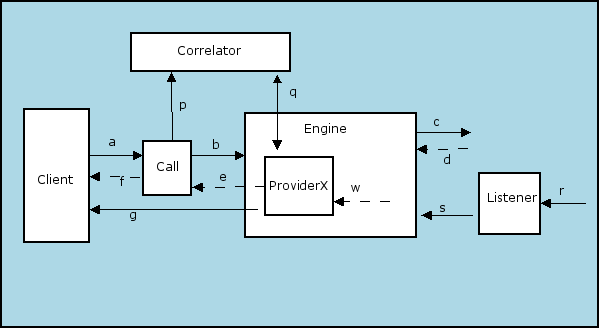

Call Class consist of following methods (Call API)

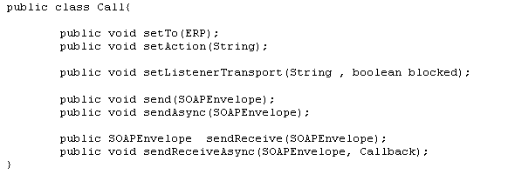

Callback Interface

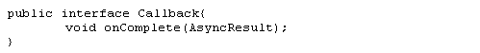

AyncResult

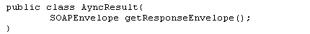

Correlator

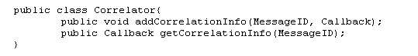

9.1 sendAsync Invocation
This invocation is similar to fire and forget, just send the request and dose not accept at least acknowledgment. And invocation will consist of following steps;
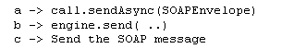
Code Snippet:
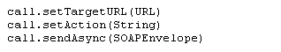

Sequence diagram

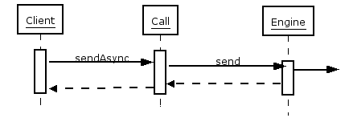

9.2 send Invocation
The service invocation is a void invocation. No return value, but wait for acknowledgment or SOAP Fault and it is consisting of the following steps.

a -> call.send(SOAPEnvelope)
b -> engine.send( ..)
c -> Send the SOAP message
Code Snippet:
call.setTargetURL(URL)
call.setAction(String)
call.send(SOAPEnvelope)

Sequence diagram
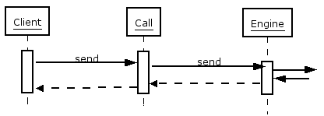

9.3 sendReceive Invocation
The service method has a response and the communication happens synchronously using a bi-directional protocol. Client hangs until the response (or fault) is returned.

a -> call.sendReceive(SOAPEnvelope)
b- > engine.send (..)
c -> Send the SOAP message
d -> Receive the response over the synchronous transport
w -> ProviderX will be called as the last step in engine.receive(..)
e -> provider returns
f -> Call hand over the response to the client

Code Snippet:
call.setTargetURL(URL)
call.setAction(String)
SOAPEnvelope env=call.sendReceive(SOAPEnvelope)

Sequence diagram
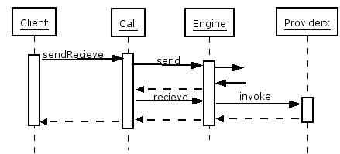

9.4 sendReceiveAsync Invocation
The service method has a response and the communication happens synchronously using a bi-directional protocol. Client DOES NOT hangs until the response (or fault) is returned. Client uses callback mechanism to retrieve the response. Call API uses threads from a thread pool for each invocation.

a -> call.sendReceiveAsync (SOAPEnvelope, callbackObj)
p -> correlator.addCorrelationInfor(msgID,allbackObjRef)
b- > engine.send (..)
c -> Send the SOAP message
d -> Receive the response over the synchronous transport
w -> ProviderX will be called as the last step in engine.receive(..)
q -> correlator.getCorrelationInfo(msgID)
g -> callbackObj.onComplet()
Code Snippet:
call.setTargetURL(URL)
call.setAction(String)
call.setListenerTransport(“http”, true)
call.sendReceiveAsync (SOAPEnvelope, Callback)

Sequence diagram

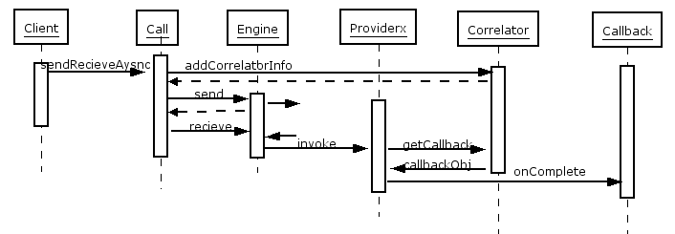

9.5 sendReceiveAsync Invocation with One way transport
The service method has a response and the communication happens asynchronously using a uni-directional protocol. Client DOES NOT hangs until the response (or fault) is returned. Client uses callback mechanism to retrieve the response. Call API uses threads from a thread pool for each invocation.

a -> call.sendReceiveAsync (SOAPEnvelope, callbackObj)
p -> correlator.addCorrelationInfor(msgID,allbackObjRef)
b- > engine.send (..)
c -> Send the SOAP message
r -> Receive the response by the listener
s -> engine.receive(..)
w -> ProviderX will be called as the last step in engine.receive(..)
q -> correlator.getCorrelationInfo(msgID)
g -> callbackObj.onComplet()
Code Snippet:
call.setTargetURL(URL)
call.setAction(String)
call.setListenerTransport(“http”, false)
call.sendReceiveAsync(SOAPEnvelope, Callback)

Sequence diagram

